Interdisciplinary course of

**Design and Robotics**

5° edition, 2017

Professors:

Andrea Bonarini, DEIB department, Politecnico di Milano

Maximiliano Romero , DPAC department, Università IUAV, Venezia

Tutors:

Andrea Brivio, Yael Bendit,

Students:

Moreno Sardella, school of Computer Science and Engineering

Dimitar Anastasovski, school of Computer Science and Engineering

Lorenzo Vignati, school of Biomedical Engineering

Paolo Ritter, school of Biomedical Engineering

Luca Fochetta, school of Computer Science and Engineering

# Index

Index 2

Abstract 3

Description 3

Research 4

State of the Art 4

Inspiration 5

Representation 6

Development 7

Interaction 7

Shape 8

Mechanics 9

Electronics 9

Informatics 10

Conclusion 11

Bibliography 11

Annex 11

Interaction 11

Bill of Materials 11

Shape 13

Mechanics 14

Electronics 14

Informatics 15

# Abstract

Our work consists in the projection and construction of a first prototype for a robot, whose goal will be to attract people and make their curiosity drive them into a certain restaurant.

We chose to advertise a fish restaurant, but most probably not a sophisticated one, in fact our robot will be an attraction more for kids than for adults. The base idea is to have more than one robot, shaped as little hermit crabs that will run on a platform with the menu of the restaurant, and will emit acute sounds and light to attract attention.

The presence of sensors will make them act as they are scared when people approaches the menu, at which point a bigger hermit crab will start to interact with the person.

This first prototype is a single robot, way bigger than the final product, because of the difficulties encountered in the miniaturization, and without any form of interaction.

The final result was a robot with a nice hermit crab shell made of a polymeric spongy material, that could move in circles and on 8-shaped trajectories, while lifting its shell up and down as if the little inhabitant inside was peeping out from his home.

In the second version of the robot we managed to reduce the dimensions of the base to values suitable for being put on a restaurant menu without becoming an obstacle for who tries to read. This could be achieved thanks to smaller components bought expressly for this scope and also to the possibility to use an FDM 3D printer to create a custom base.

The other main change is the presence of many sensors that allow the combination of different movements with the ability to avoid obstacles and stay inside a precise area without trespassing a black peripheral line.

In the third version of the robot we managed to introduce a second hermit crab (unfortunately its Arduino stopped working so weren’t able to show it) and an Oyster that will perceive people presence and advice the hermit crab. The oyster will also make some music and control a small bubble-gun that will shoot bubble if no one is in front of the menu.

In the fourth version we substituted the broken Hermit ‘s PCB, we changed the Oyster with a Treasure Box and menu shape. We also substituted the shells of the Hermit Crabs to make them less heavy.

# Description

The purpose of the project is to build an autonomous robot able to interact with people in order to promote a restaurant. Our idea is to build multiple robots with the appearance of hermit crabs that will be able to understand when a person is approaching them and go hide (under their shells). Then they will start slowly to come out from the shell and start to do some movements and attract attention with sound and light. For the first prototype, we built an hermit crab able to move around and lift his shell without any remote control or external alimentation. The second one was capable of moving randomly and, exploiting his sensors, avoiding obstacles and dark regions of the floor.

Our concept is a family the hermit crab-like robots of which two will be very small, but also very active, being able to move around, while the third one will be bigger and will not have wheels, but will feature the abilities to shoot soap bubbles, detect the presence of possible customers and emit more complex sounds.

Through infrared communication between the mother hermit crab and the two little ones, these two will also be alerted of the presence of customers and react escaping and showing fear, while the big one will interact speaking to the people.

With the third prototype we slightly modify the concept of family of hermit crab because we decided to substitute the “mother” of the hermit crab with an Oyster. The small hermit crab, in case of people presence, will go outside the menu and follow a black line until the people will go away; this is done to allow the consumers to read the menu.

In the fourth prototype we modified the menu: now it has a round shape, it’s bigger and it can be folded. The menu has a total radius of 30 cm, where the white part has a radius of 26 cm and it’s situated in the inner part of the menu; the remaining part is made of black paper.The decision to modify the menu was taken after we encounter many issue with the Hermit Crabs getting stuck on the angle of the squared menu. We also subsisted the shells of the hermit crabs with new ones (of polyurethane resin) to let them be lighter than before. This decision was taken after many attempts with both the shaft and the Shells to implement correctly the pop up. We tried to modify the third prototype of the Oyster by painting it and cutting it to have a better appearance; in the end we decided to substitute it with a Treasure Box to have the space to place all the components; it was done also to achieve a good appearance. The Treasure Box will always stay open and will do the same operation that should have been done previously from the Hermit Crab.

# Research

## State of the Art

The state of the art are two different projects, both much different from ours, but still for some aspects similar.

The first one is made by Cepia and is called Xia Xia. It is made for kids and the main attraction are the four little hermit crabs with interchangeable shells that can move around autonomously (but without sensors and steering mechanisms they can only move straight forward and backward). What we take from this project is the presence multiple little robots, but what will distinguish our work is the presence of many sensors and a much more complicated algorithm that will allow real interaction with both the other crabs and the people.

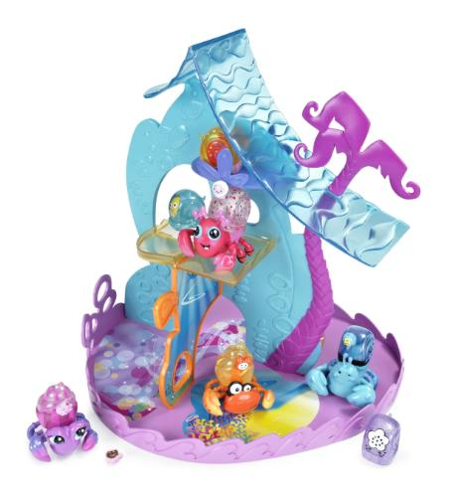

Figura https://www.youtube.com/watch?v=46KlwGfh8VM

The second project is a more complicated robot, that like ours can go around without getting stuck into obstacles, but lacks the aesthetic side and the functions that will allow our robot to interact not only with the environment, but also with people.

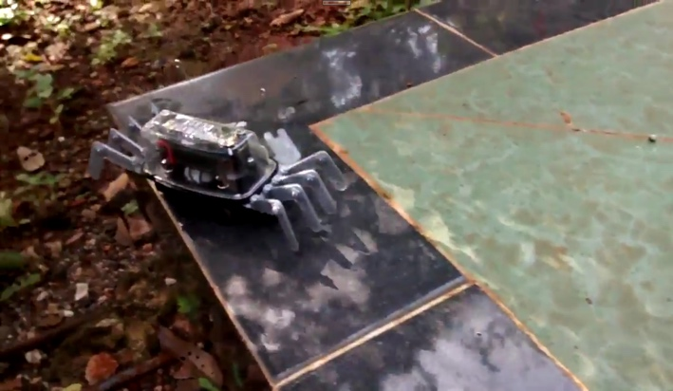

Figura https://www.youtube.com/watch?v=gbPtuy5Ew8Y

## Inspiration

The inspiration arrived from an interesting project made by Japanese artist, Aki Inomata. She 3D printed shells shaped externally as landscapes of important cities (like New York for example) and internally as a natural shelter for the crabs (after studying the structure with micro CT scans). The aim of her project was to stress the relationship between an inhabitant and his home. As the hermit crabs growing change their shells so pieces of land pass from one nation to one another, sometimes even peacefully.

/*

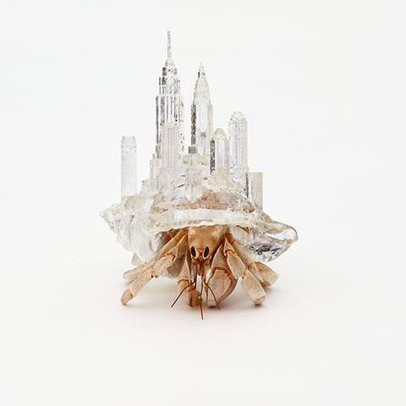

Figura 3 3D printed transparent shell by artist Aki Inomata

## Representation

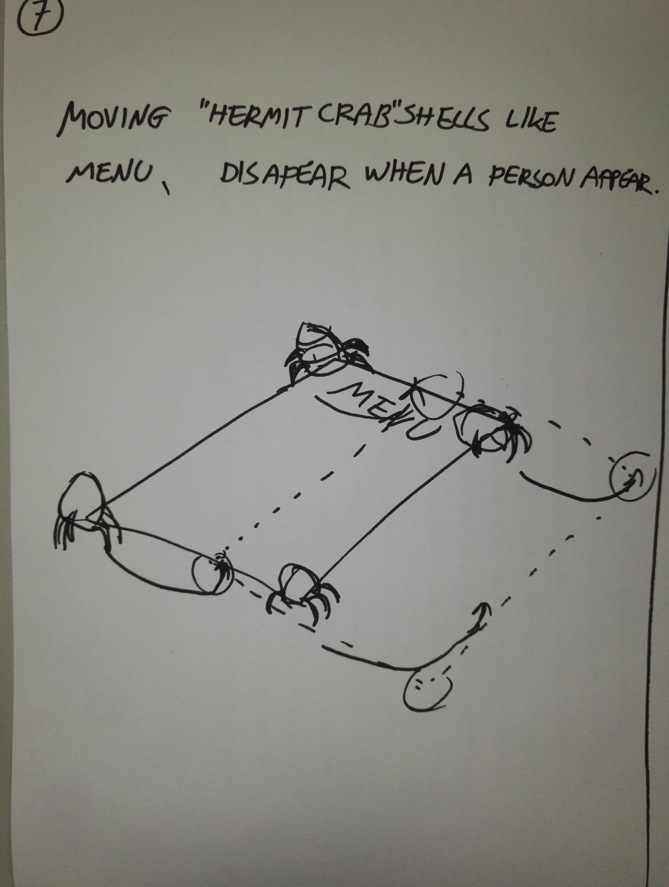

Figura 4 Preliminary sketch of the two crabs on the menu.

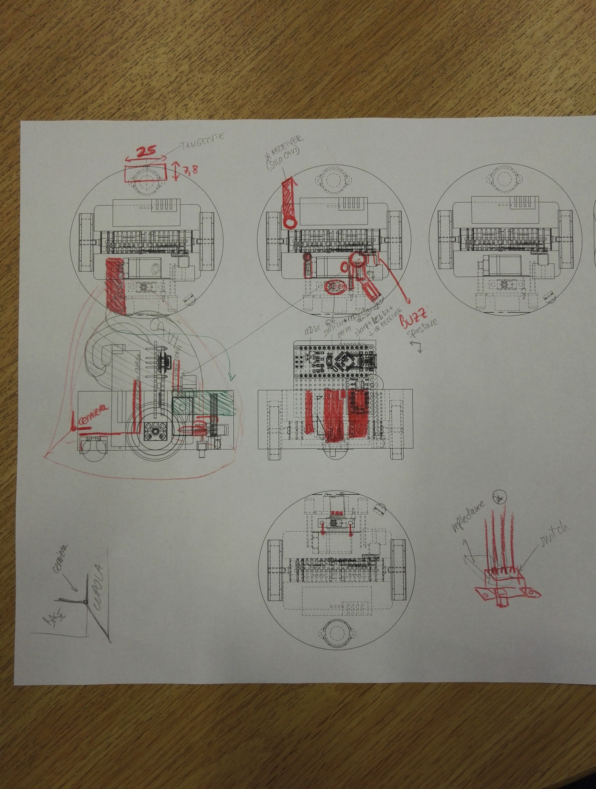

Figura 5 Sketch based on the projections from the cad modeling.  
This helped us with the disposing of components and cables.

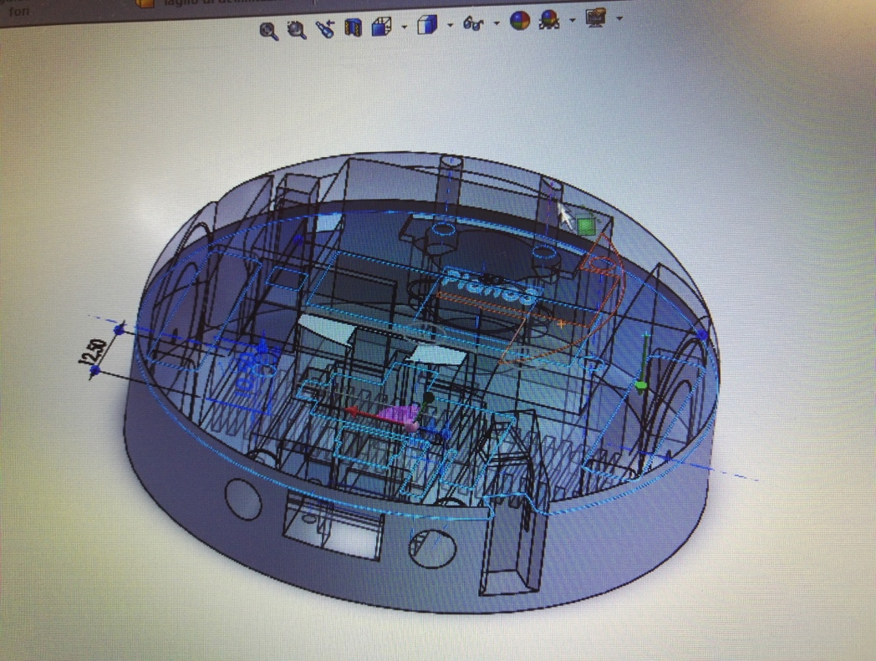

Figura 6 image taken from the processing of the 3D cad model.

# Development

## Interaction

* First prototype:

For the first prototype our attention was focused on the creation of a robot that besides being able to show his main functions, could give a first demonstration of how small we want it to be. For this reason, most of our effort was spent fitting all the needed components in a relatively small ‘shell’ in the most efficient way and making it so it could work without external sources of power.

* Second prototype:

In the second version, although being again much focused on the miniaturization of the robot, we had enough time to implement interaction with the surrounding environment.

We installed on the front side of the robot a proximity sensor to detect obstacles on his path and make it avoid collisions. This function will help mostly crashes between the two robots, since the containment of the movements inside a precise area is achieved thanks to a reflectance sensor installed in the inferior part of the base; this sensor will be used to detect a black line that will be placed around the perimeter and the robot will use this information to turn round and continue moving in the area where it is allowed to stay.

Third prototype:

For the third and final version on top of the two hermit crabs are installed cages and on top of the cage the shell will be placed. Thanks to a servo they will be able to move up and down the shell. Also it was developed a third robot called “Mother hermit crab” that is going to be static but very important. The job of robot is sensing the surrounding environment with three ultrasonic sensors and whenever someone is approaching send a signal using the IR emitters to the other hermit crabs asking them to move outside of the menu. Additionally, a bubble gun is installed which will produce soap bubbles in order to attract people. Finally, we created a menu where the hermit crabs are going to move. In addition, improvements of the algorithm are made for smoother and better interaction and performance.

Fourth prototype:

In the fourth prototype we solved the electronical problem of the second Hermit Crab.

The Hermit Crabs now will be scared when someone approach the menu: they will close the eyes and theirs shells. After few seconds they will open again the eyes, pop up the shells and then go to the border of the menu.

When someone approach the menu the Treasure Box will play some invitation spot to convince the customer to go inside the restaurant.

A big issue we encountered was the two Hermit Crabs clashing against each other; many time caused by the fact that they don’t see each other.

## Shape

* First prototype:

The shape of the robot is the one of a hermit crab, with a big conic shell. It was made with two wheels at base in order to make it move.

* Second prototype:

The shape of the prototype reminded mainly the same of the first prototype, but in the second version we managed to reduce further the diameter of the base and the dimension of the whole structure, since we were able to find very tiny components and use the FDM technique to 3D-print the base and mechanical support for the robot. We made our best to be precise in every step of our work, since we want to use this second prototype as one of the two definitive little robots needed for our project.

Third prototype:

The shape is improved with a new 3D printed cage that is attached on the top of the little hermit crabs and on top of that the shell will be placed. The mother hermit crab shape is hand made with polyurethane and paper and coloured with acrylic paint. The final shape is changed from the one of an Hermit Crab to the one of a Oyster that will be placed on top of small base.

Fourth prototype:

The shells were white painted with both acrylic colour and paint, but they were too heavy to pull up, independently from the shafts we used (obviously the paint wasn’t the cause).

The Hermit Crabs shells’ shape now is changed due to the modification done to make them less heavy (now are made of polyurethane resin).

The Oyster has been modified to have a better look: now it has become a Treasure Box full of coins. This modification was made after many attempts to modify the previous prototype of the Oyster to achieve both a better appearance and enough space for all the components (it was painted and modified by cutting some parts to make enough space for all the components).

## Mechanics

* First prototype:

The first prototype was built using a circular rigid plastic base we cut from a sheet on top of which we disposed the batteries, the motors (making the wheels pass through the base) and on top of them the servo motor with its shaft. On the back of the base we put a hinge to make possible the rotation of the shell around a fixed axis allowing the opening from the front due to the “popping up” of the shell itself.

* Second prototype:

The mechanical part of the robot is mainly the same seen in the first prototype, although the components were all exchanged with smaller versions.

The main difference is that the base was now thought in order to be a 3D printed solid volume in which we could fit the components thanks to proper housings.

Third prototype:

For this prototype the final mechanics improvement are the 3D printed cage on which the shell is attached. On the bottom of the cage, a servo is installed in order to move the shell up and down that give real look and interactions of a hermit crab. We did also a custom 3D model that will be attached to the bubble gun in order to trigger it.

Fourth prototype:

Many mechanisms have been tested and discarded to implement the pop up on the Hermit Crab. In the end we choose to use a shaft similar to the one used on the first prototype.

Due to the modification done to the Oyster, the bubble gun’s trigger has been modified, instead of being attached directly to the bubble gun it’s attached directly to the Treasure Box.

## Electronics

* First prototype:

We used Sparkfun Dual Tb6612FNG as motor driver to control two DC motors. As microcontroller we used an Arduino Nano Atmega AT320p to which we connected the driver and the servomotor. The robot is power supplied trough two alkaline battery at 9 volts.

* Second prototype:

The main difficulty for the electronics was to use small sensors (the biggest one is approximatively 10 mm x 20 mm) able to perceive an obstacle in front of the Hermit Crab or the different colour under the robot. In addition, we have two micro motors controlled trough a motor driver able both to supply and control them by using three pins for each motor. Also a servo is connected directly to the board and it will be used to pull up and down the shell of our robot. Two pins are used for two IR Receivers that will have to receive some commands coming from a bigger hermit crab. As microcontroller, in order to keep small the robot, we used an arduino nano. We use a 7.4V Li-ion battery in order to supply all the components. Two small LEDs are used as “eyes” of the Hermit Crab and they are connected directly to a digital pin.

Third prototype:

Everything remains the same for the little hermit crabs. For the mother hermit crab an Arduino Uno is used on which three ultrasonic sensor are attached together with an IR emitter able to send signal whenever someone is in the front of it. A bubble machine is mounted and is controlled with a servo motor. Finally, we add a microSD reader that is connected to two speakers that will emit sound.

Fourth Prototype:

Solved the problem with the second Hermit Crab by changing the Arduino Nano and the MotorDriver. We also add a capacitor between the 5V and the ground of Arduino to let the servo work.

We also printed a PCB for the Treasure Box and changed the power supply in order to use only one of them.

## Informatics

* First prototype:

We used the library servo.h to control the servomotor whose job is to lift up and down the shell of the hermit crab. The problem we faced was of mechanical origin: the self-made wheels could not be perfectly symmetric, but we managed to solve it by making one motor go slower than the other one.

* Second prototype:

We used three pin to control the rotation of each motor where two pins are used for direction and one for the speed (PWM pin). In order to easily integrate the movement in our code, we create different functions for each kind of movement (go forward, backward, turn, spin). These functions are called randomly from a “mother function” so that the movement cannot be predictable. We used a function for a digital proximity sensor that tell us if an object is closer than ten centimetres from the head of the Hermit Crab. Another function is used for a reflective sensor put under the robot used to see the colour of the table. The function return BLACK if the value is over a certain threshold, WHITE otherwise.

Third prototype:

In the final version of the Hermit Crab we used a custom PID algorithm able to autonomously move and adjust the speed while is it moving on the black line, that is giving also some level of artificial intelligence to the hermit crabs. Additional code is write in order to handle the communication with the third robot. This robot will use three ultrasonic sensors connected to digital pins that will perceive the presence of people in front of the robot and in case will advice the hermit crabs with an IR packet send with IR emitters. In addition we used servo connected to a PWM pin able to trigger the bubble gun. For the final touch we add an microSD reader module that is connected to two speakers and is controlled by serial communication by arduino.

In addition, we used one library in order to send and receive IR packet (IRremote) and a library in order to interface the oyster with the ultrasonic sensor(NewPing). We had to modify slightly the NewPing library in order to use it together with the IRremote( they were trying to use the same timer in Arduino Uno, we disable the timer option from the NewPing library).

Fourth Prototype:

We add to the Hermit the feature of being scared when someone approach in front of the menu. With the “introduction” of the second Hermit Crab we encountered many problems with the collision avoidance since the two Hermit have some problem to see each other. We made many test in order to solve this issue.

A new function has been added to the Treasure Box: when a customer approach to the menu, the Treasure Box will invite the customer to come inside the restaurant.

# Conclusion

We learnt about the difficulty of using a small case without having problems arranging the huge mass of cables and all the mechanical parts and about the big amount of energy and power needed by a system like this, which must never be underestimated.

With the second prototype we understood how difficult is to try to realise something that should be the final version of the robot at just the second attempt. This led us to dedicate too much time to resolving problems given by the miniaturization and the assembly and we didn’t focus enough on the interactive aspect.

With the third prototype we encounter the same problem we had with the second prototype, focusing too much in the design of the Hermit Crab and we took too much time to do that, and we had less time to integrate everything(informatics part and physical part) which lead us to fail in many aspect of it.

In the fourth prototype the most difficult part was to re-design both the Oyster(made from scratch) and the shaft for the Hermit Crabs. Those tasks have taken most of our time, together with the identification of the electronical problem on the second Hermit Crab. Another big issue we deal was to modify the shell’s weight finding a proper material.

# Bibliography

<http://www.aki-inomata.com/works/hermit/>

<https://www.youtube.com/watch?v=46KlwGfh8VM>

<https://www.youtube.com/watch?v=gbPtuy5Ew8Y>

<https://www.arduino.cc/en/Tutorial/HomePage>

<https://www.arduino.cc/en/Guide/ArduinoNano>

# Annex

## Interaction

Flowchart of interaction

## Bill of Materials

**Robot Store:**

|  |  |  |
| --- | --- | --- |
| Object | Number of piece | Prince (Total) |
| Servo Micro HD-1550A | 3 | 15,90 € |
| HC-SR04 (Distance Sensor) | 3 | 6,30 € |
| Rubber Wheel 32x7mm(2pz) | 2 | 9,20€ |
| Analog Reflectance Sensor | 2 | 3,80€ |

**Robot Italy:**

|  |  |  |
| --- | --- | --- |
| Object | Number of piece | Prince (Total) |
| TB6612FNG Motor Driver Pololu | 2 | 13,46 € |
| Ir Digital Sensor 10 cm(Distance) | 2 | 15,96 € |
| Ball Caster 12,70mm Metal Ball | 2 | 5,42€ |
| Ir Receiver/Demodulator | 6 | 12,68€ |
| Infrared Led 940 nm (10pz) | 1 | 5,21€ |

**Amazon:**

|  |  |  |
| --- | --- | --- |
| Object | Number of piece | Prince (Total) |
| Dc Motor Micro Gear | 4 | 45,00€ |
| LP-e8 Battery (2 pz) | 1 | 12,99€ |
| LP-E8 Battery Charger | 1 | 13,99€ |
| Pololu Reflectance Sensor Pololu | 2 | 6,00€ |
| BubbleGun | 1 | 6,00€ |
| DFPlayer | 1 | 11,99€ |
| *Treasure Box | 1 | 20,95€ |
| *Treasure Coins | 2 | 16,77€ |

**Ebay:**

|  |  |  |
| --- | --- | --- |
| Object | Number of piece | Prince (Total) |
| *TB6612FNG Motor Driver Pololu | 1 | 7,01€ |

**WarHammer Shop:**

|  |  |  |
| --- | --- | --- |
| Object | Number of piece | Prince (Total) |
| Sand | 1 | 9,00€ |

**Leroy Merlin:**

|  |  |  |
| --- | --- | --- |
| Object | Number of piece | Prince (Total) |
| Small Hinges (6 pz) | 1 | 3,00€ |
| Big Hinges (8 pz) | 1 | 7,00€ |
| Wood Plates | 3 | 6,00€ |
| Various Screw | 3 | 3,00€ |
| Felts(4 pz) | 1 | 3,00€ |
| Polyurethane Paint | 1 | 5,87€ |
| Vinavil | 1 | 4,12€ |
| Acrilyc Colour (Gold) | 1 | 2,98€ |
| Spray Color (Black) | 1 | 9,20€ |
| *Spray Color (Gold) | 1 | 9,90€ |
| *Polystyrene balls | 4 |  |
| *Glue | 1 | 12,90€ |
| *Acrylic Colour (White) | 1 | 3,00€ |
| *Acrylic Colour (Red) | 1 | 3,00€ |

**Other Shops:**

|  |  |  |
| --- | --- | --- |
| Object | Number of piece | Prince (Total) |
| Speaker | 2 | 5,00€ |
| Female Pin Connector(20 pz) | 2 | 2,00€ |
| Servo 9g | 1 | 5,00€ |
| 3D Printer Material | 1 | 20,00€ |
| AAA Battery (4 pz) | 1 | 6,00€ |
| D Battery 9V | 3 | 16,00€ |
| Switch | 4 | 2,00€ |
| PCB | 3 | 4,00€ |
| Arduino Nano | 4 | 16,00€ |
| *Shell | 2 | 50,00€ |

*Materials bought after the final delivery of May.

## Shape

|  |  |
| --- | --- |
| Figura 7 mechanical backend of the first prototype. | Figura 8 first version of the shell. |

3D model of the second prototype: <https://drive.google.com/open?id=0B51cJQYbwQ2adlE5M1NEWlhTNkE>

## Mechanics

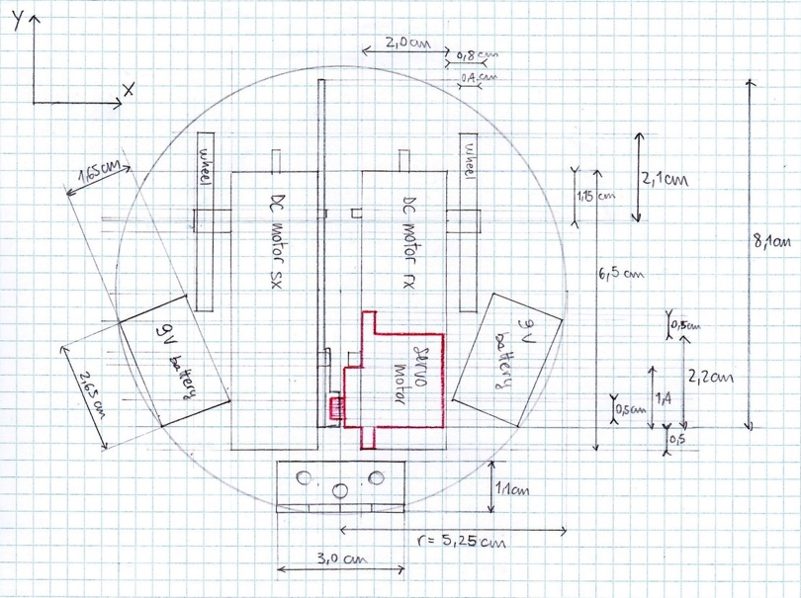

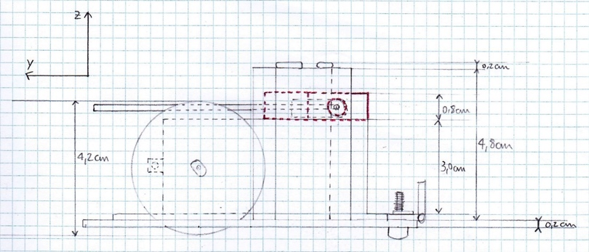

## Electronics

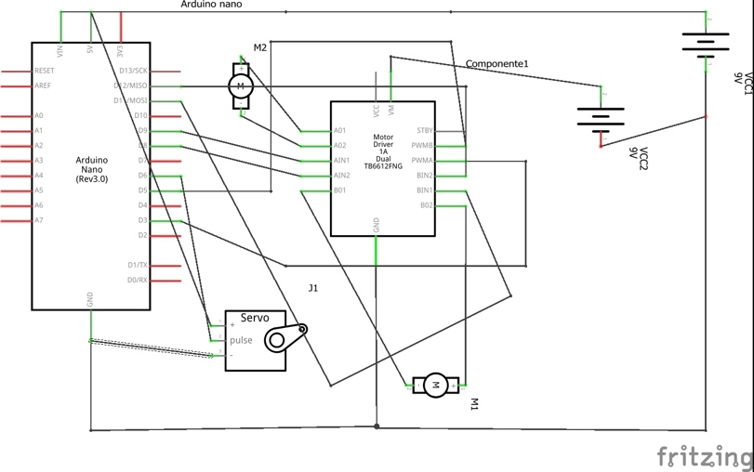  
Figura 11 first prototype

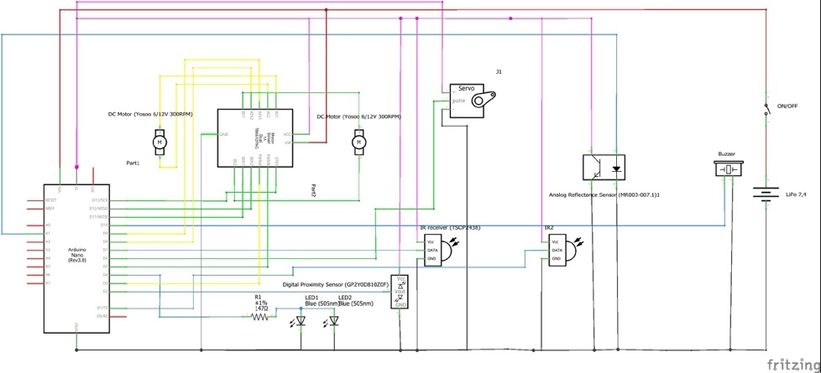  
Figura 12 second prototype

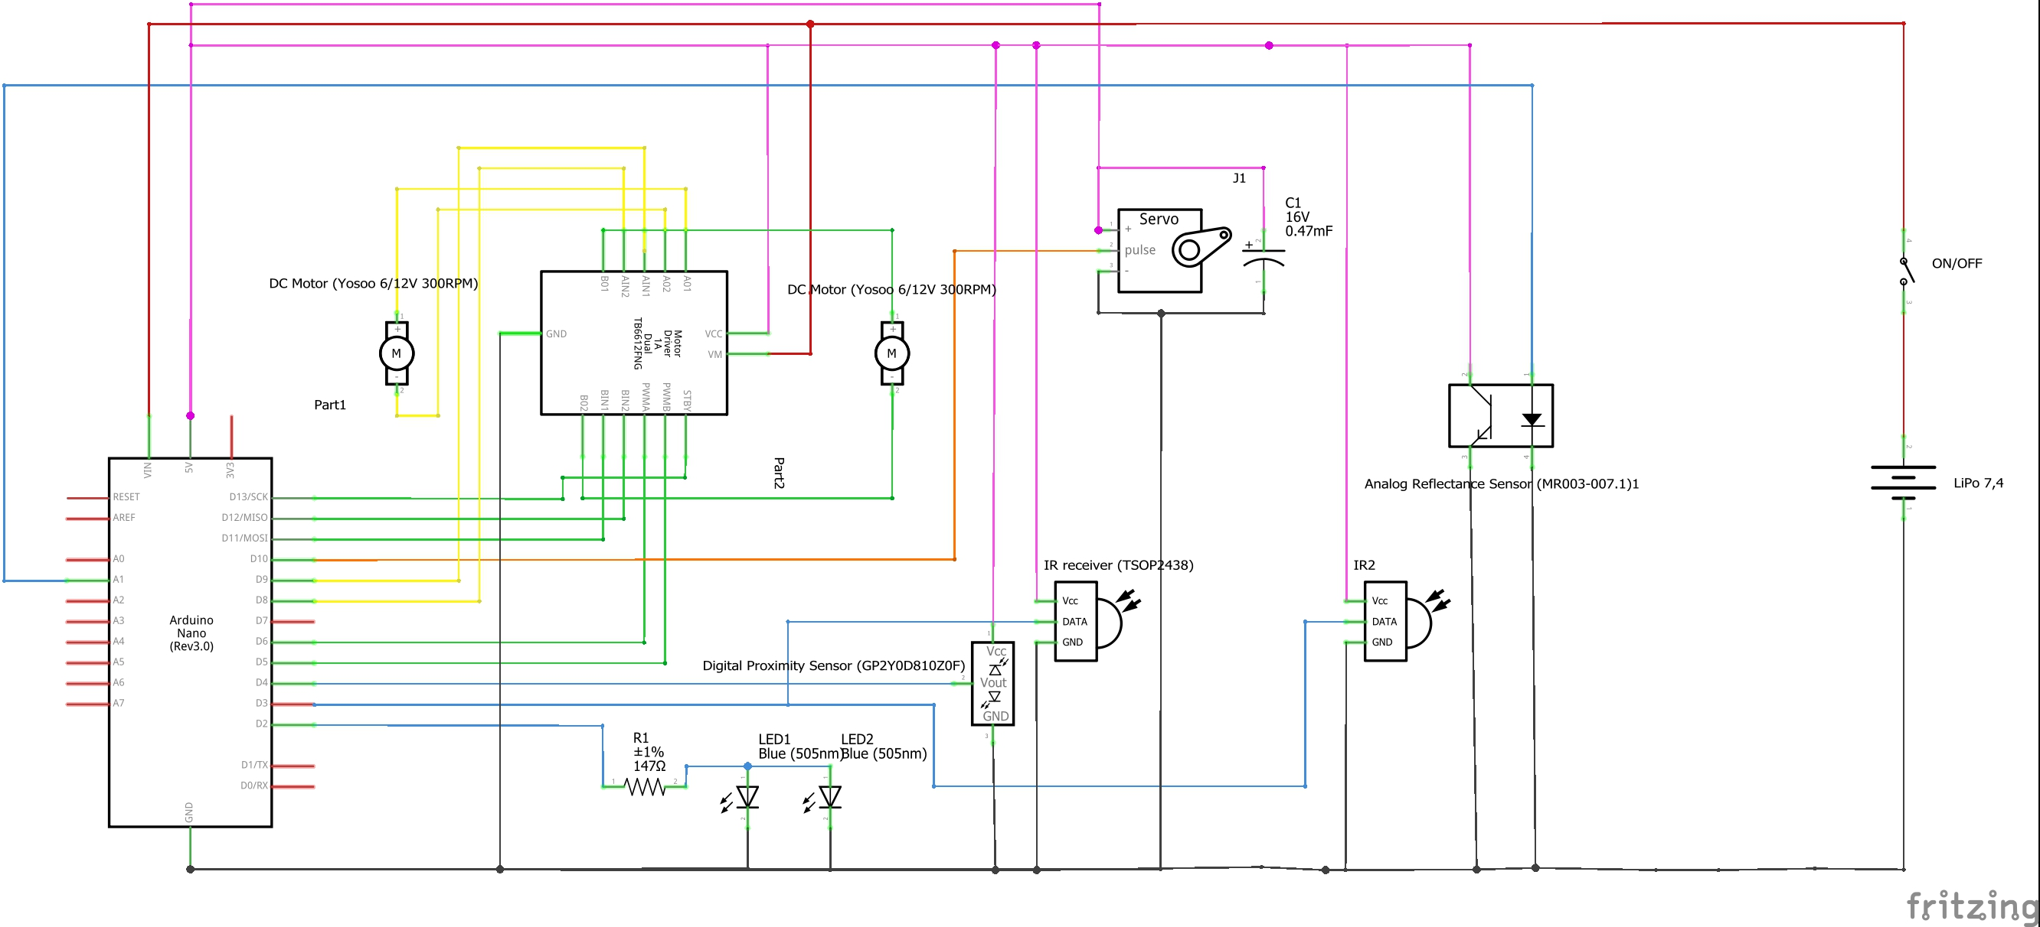

*Figura 13 Hermit Crab third prototype*

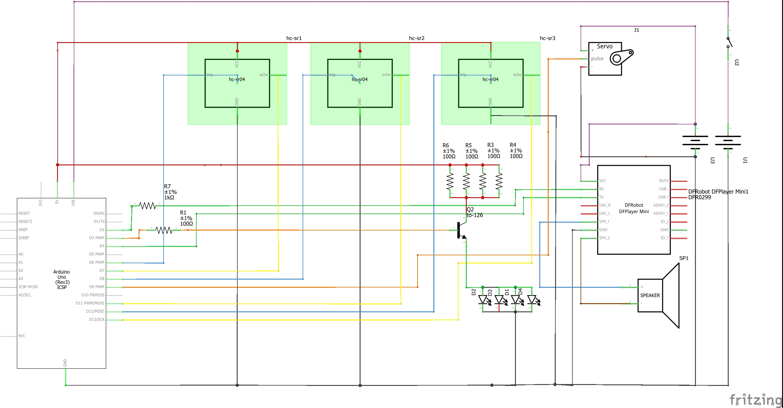

*Figura 14 Oyster schema third Prototype*

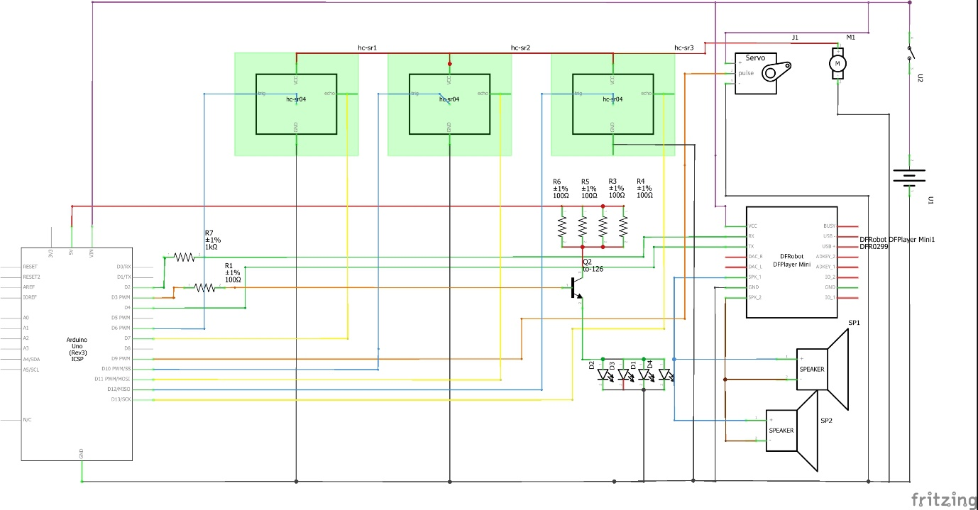

*Treasure Box(Oyster) final prototype*

## Informatics

Code: <https://drive.google.com/open?id=0B51cJQYbwQ2aNlA0TE5vcHZDeUU>

Final version sketches and libraries:

https://github.com/fochetz/RD2017_03-HermitCrab/tree/prototype3/sketch